**PRE-LAB REPORT**

**Experiment No :** 04

**Name of The Experiment :** Study of BJT amplifier using voltage divider

bias.

**Circuit Diagram :**

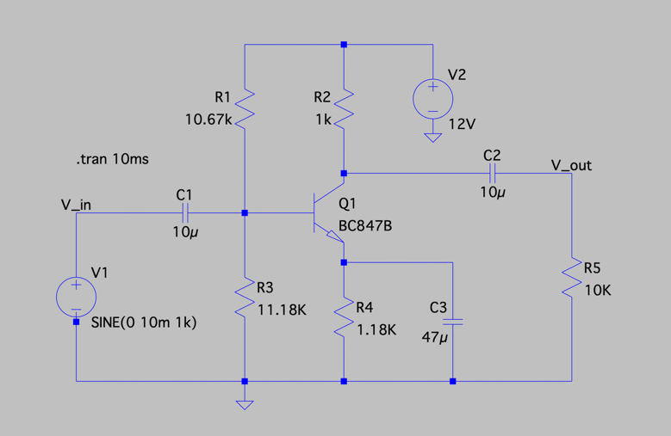

**Input & Output :**

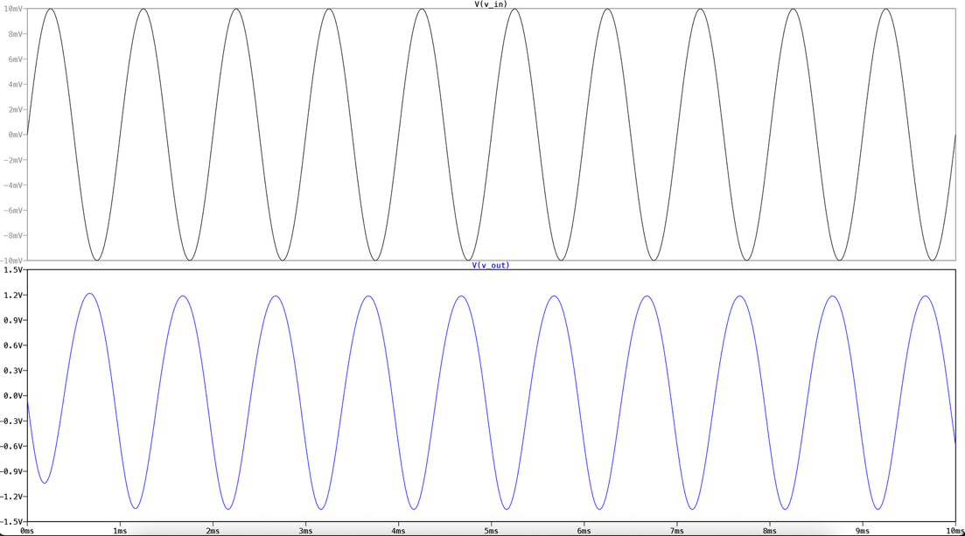

**Summary:**

This experiment demonstrates a BJT amplifier using voltage divider bias. A 10V, 100Hz sine wave was used as input. The circuit, built around a BC547B transistor, amplified the input signal, confirming the proper functioning of the amplifier configuration.